Example - Single versus Dual Element Close-up Lenses
Prepared 2006-04-17 (155/7281) by Bill Claff
D70 18-200mm VR @200mm VR off f/8 1/60s ISO 200 SB-800 on camera on focusing rail at closest focus.
100% crops with contrast adjusted to accentuate the differences.
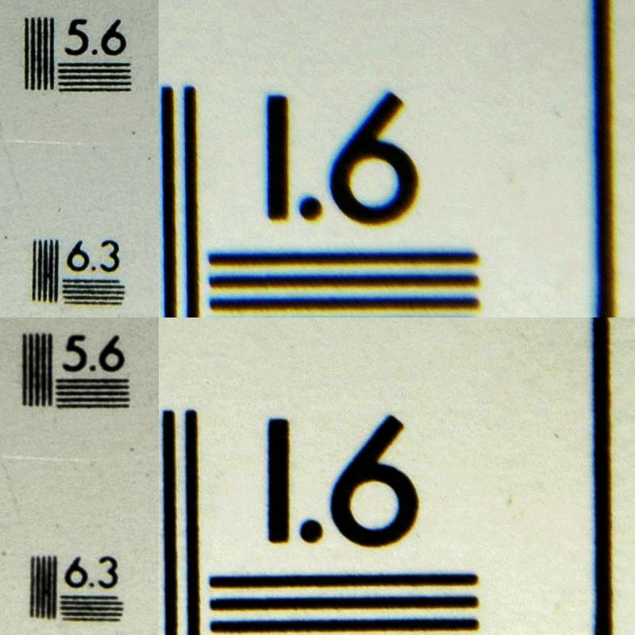
Left-hand-side is the center.
Right-hand-side is the lower-right corner.
Top is a Hoya +2D single element close-up lens.
Bottom is a Canon 500D (+2D) dual element close-up lens.
The results are self-evident.

