Examples - 18-200mm with Close-up Lens versus 50mm with Extension Tubes
Prepared 2006-02-19 (169/6129) by Bill Claff
Just some quick hand-held shots to give you some idea.
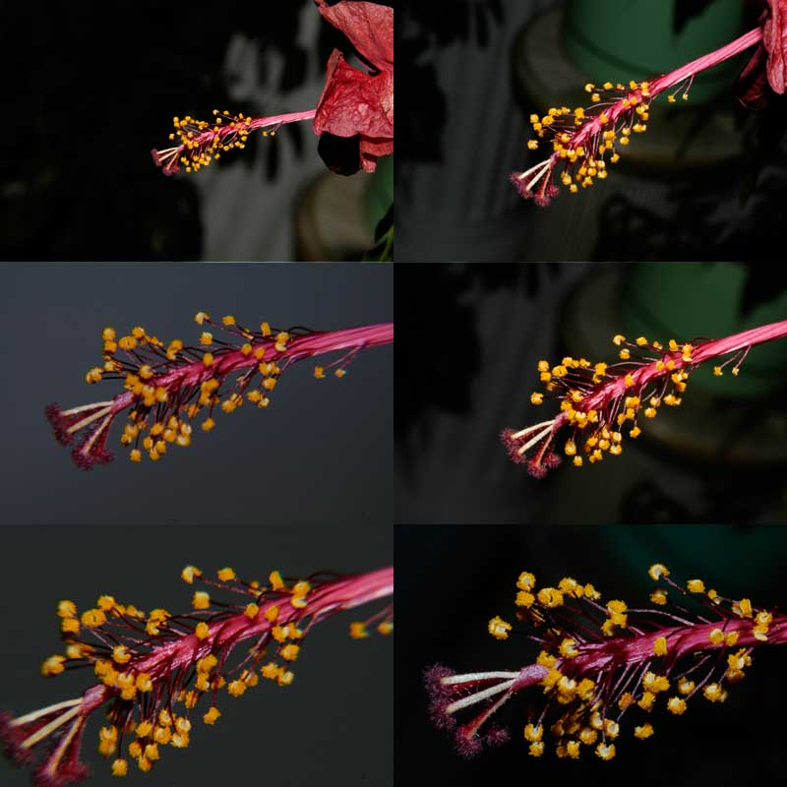
200mm (.25x @245mm) | 50mm +12mm tube (.41x @135mm)
200mm +3D (.61x @340mm) | 50mm +20mm tube (.52x @110mm)
200mm +4D (.82x @215mm) | 50mm +36mm tube (.84x @75mm)
Magnification and approximate Working Distance in parenthesis.
The close up lens shots were taken at infinity focus; all others at closest focus.
All D70 ISO 200 with built-in speedlight.
200mm is the 18-200mm f/3.5-5.6G ED-IF AF-S VR DX Zoom-Nikkor
50mm is the 50mm f/1.8D AF Nikkor
+3D is approximately a Nikon 6T.
+4D is approximately a Canon 250D.
I don't own either close up lens so these were taken with a cheap Hoya close up set.
The tubes are the Kenko Extension Tube Set DG
You can go much closer with the tubes but at about 48mm of extension the built-in speedlight casts a shadow; so I use my SB-800 at that point.

