Measuring Magnification
Prepared 2005-11-09 (169/4554) by Bill Claff

Introduction
The classic method for measuring photographic magnification is the “ruler” shot. A refinement of this technique is to use the computer screen as the ruler.
The computer screen has some distinct advantages.
One advantage is that the screen is naturally backlit so lighting and exposure are simplified.
The chief advantage is that very fine and regular patterns can be created so that magnification can be determined with relatively high precision.

Some Rulers
6 Pixels per Line Pair
This pattern is suited to less magnified images.
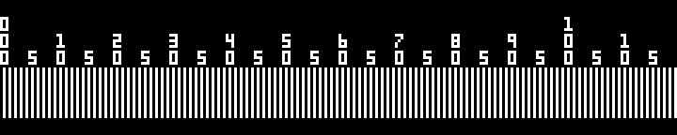
2 Pixels per Line Pair
This is a good all around pattern for measuring magnification.
1 1/3 Pixels per Line Pair
This pattern is suited for high magnifications or when the highest precision is desired.
Best used on an LCD panel or Sony Trinitron monitor.
(Takes advantage of the vertical RGB stripes to obtain a very fine ruler.)

An Example
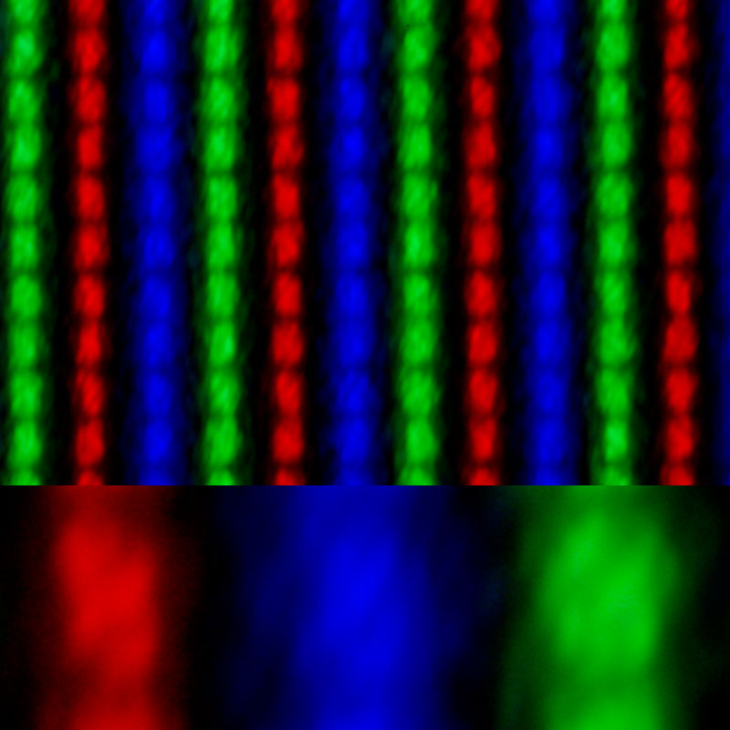
The top portion of this example is a full frame image of the finest ruler.
The bottom portion is a 100% crop from the image.
This picture was taken with a Nikon D70 and a 12-24mm f/4G ED-IF AF-S DX Zoom-Nikkor at 12mm reversed on 68mm of Kenko Extension tubes.

On my LCD panel each LED is .170mm tall and .085mm wide.
So 10 lines pairs times 2 LEDs per pair at .085mm per LED is 1.700mm
The line pairs span 2706 pixels.
2706 pixels * .0078mm per pixel is 21.11mm

So in this example magnification is 21.11 divided by 1.700 or 12.42x

