Tip - Choosing the Right Extension in the Field
Prepared 2006-04-25 (169/7573) by Bill Claff
I've made a number of posts on various forums of close-ups and macros taken with the 50mm f/1.8D AF Nikkor and Kenko Extension Tube Set DG.
To choose how much extension I need I use an 18mmx150mm piece of cardboard that looks like this:
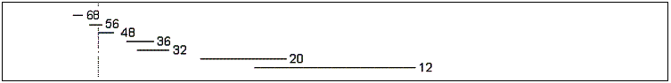
I hold it up to my subject and read off how much extension I need based on the width of the image.
Anything wider than 150mm doesn't require any extension.
Note also that there is a "no man's land" between 93mm and 150mm
So in practice 93mm wide is where you need to start adding extension.
To the right of the dotted line I can use the D70 built-in speedlight; to the left I must use my SB-800 because the built-in flash is blocked by the extended lens.
It's not too hard to prepare such a ruler and it's well worth the effort.

