D70 Histogram Investigation - Part 2
Prepared 2004-12-09 (150/119348) by Bill Claff
The x-axis of the D70 histogram is luminosity.
The histogram display is affected by the tone curve and a gamma correction so it is not obvious how the f-stops are spaced. (it's not powers of 2)
The following chart, derived from the careful measurement of 15 photos that differed only in exposure time, shows f-stop locations at 1/3 EV for the default tone curve in my camera:
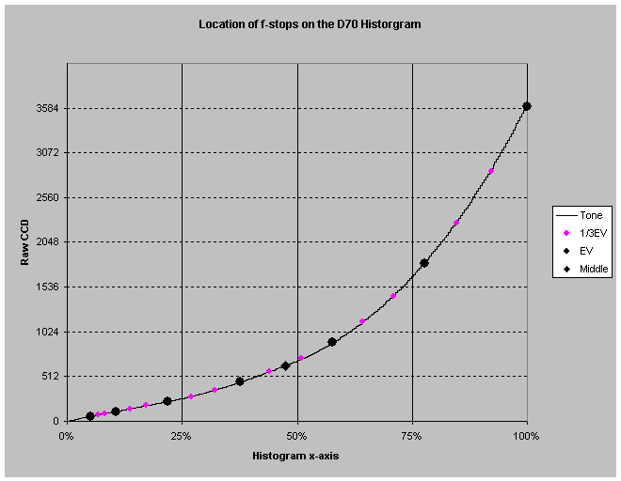
- The x-axis represents the D70 histogram x-axis
- The y-axis represents 12-bit raw CCD readings
(The curve is the tone/gamma curve)
- The circular symbols are spaced at 1/3 EV intervals
- The diamond symbol represents the middle of the automatic exposure range
(Where Auto chose to expose.)
- The chart shows about 2 1/2 stops above the middle before clipping
- The chart shows 2 1/2 to 3 1/2 EV below the middle before detail is lost
So as a first approximation the histogram (for this tone curve) can be interpreted as 5 equal size EV regions.
Let's go a step further and examine the affect of lossy Nef compression.
(See https://www.nikonians.org/cgi-bin/dcforum/dcboard.cgi?az=read_count&om=2971&forum=DCForumID86
for details.)
Consider this chart:
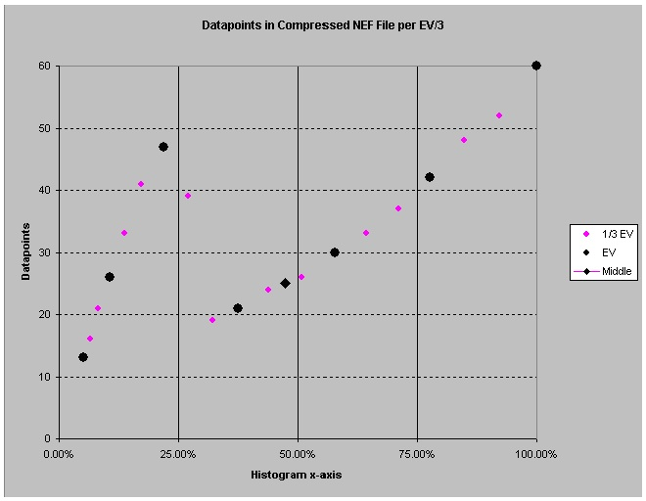
- The y-axis now represents the number of compressed datapoints for a given 1/3 EV interval
Now
- The number of useable f-stops below middle is more obvious.
- It's clear that overexposing a little "exposing to the right" improves tone (provided you don't clip)
- But you can do even better (if your image doesn't have too much shadow detail) by underexposing by 1 to 1 1/3 EV to get the "sweet spot" centered at about 22%
So, if you're willing to post-process and you understand the D70 histogram, you can get more tonal definition and results that exceed the already excellent performance of the automatic exposure system.
A final reminder, this analysis is for the default tone curve, "your mileage may vary" if you use a custom curve.

