Study in Red – Part 2
Prepared 2008-09-04 by Bill Claff

On a recent hike I noticed some stunning red flowers.
Knowing that red can be a problem; I watched my RGB histogram carefully.
Rather than simply discarding the "loser", I constructed this write-up.
Here are 33% crops from the original images:
0 EV -2 EV
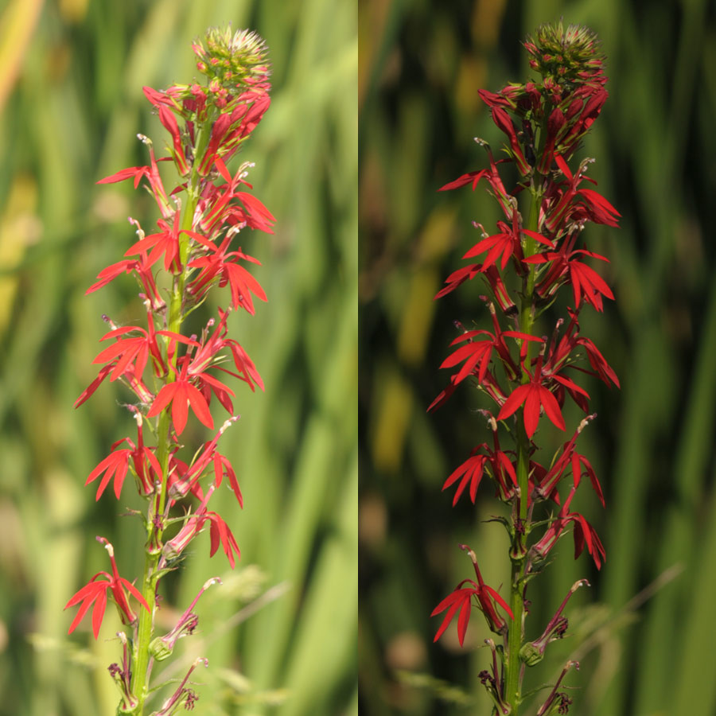
On the left is with 0 EV Exposure Compensation.
On the right is with -2 EV Exposure Compensation.
(Yes, it really took that much in this extreme case!)
Clearly the image on the left is better exposed, but we can already see there is a problem with the flowers.
Now, 33% crops that have been post processed for a consistent background exposure:
0 EV -2 EV
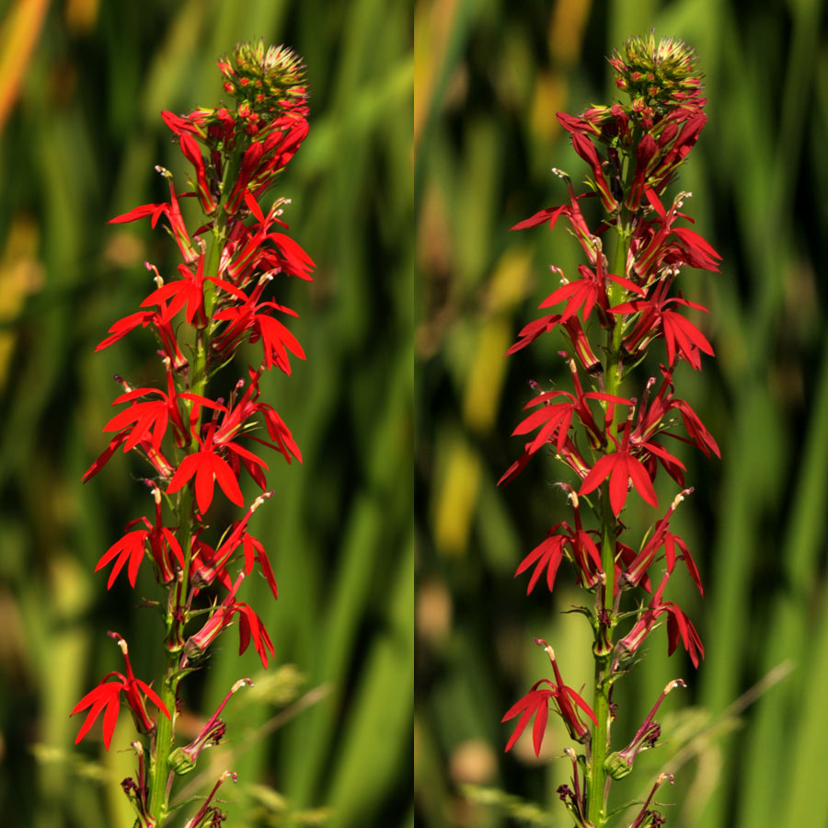
So, even though I had to underexpose the image on the right; in the end it is the far better result.
This is an extreme case, because this red is so very intense.
But these principles apply to all images with strong reds.
And never forget that yellow is 50% red.
Strong blues can also be problematic, but not to the extent of reds.

