Why You're Seeing Red
Prepared 2005-01-10 (150/98270) by Bill Claff
Many people have noted that they see red in certain circumstances.
This post explains the typical reason this happens.
Observe the following image:
Each box from left to right is 1/3 EV more exposure of the same bright white target cropped from the center of eight images.
Note that the gray goes through red before it reaches white.
This is not a defect. This is expected behavior for a CCD like that in the D70.
In the squares that you "see red", although you cannot see it, the green and blue channels are clipped and naturally this confuses the white balance.
The fact that the CCD is far less sensitive to red (and somewhat less sensitive to blue) is the root of the "problem".
Here is a chart that may help to illustrate:
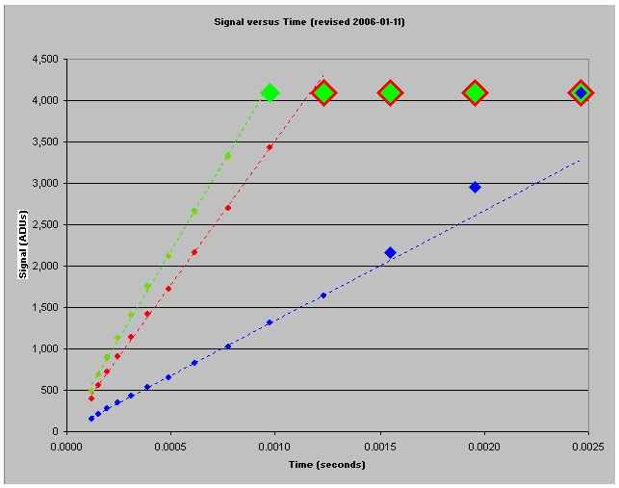
Note that red, green, and blue increase linearly with time until they get clipped at 4095.
The dotted lines indicate the linear trend for each channel.
Note that there are four exposures where green or green and blue are clipped but red is not. For those exposures the squares will appear red.
If you're following closely you'll note a factor that "adds insult to injury". The last two red values before red clips are above the trend line. This is due to "blooming". The electrons that couldn't fit in the adjacent green and blue CCD wells spilled over into adjacent red wells.

