Example - Why I Now Have Two Flashes
Prepared 2006-05-07 (154/14740) by Bill Claff
Not a great pairs of shots but it does illustrate the point:
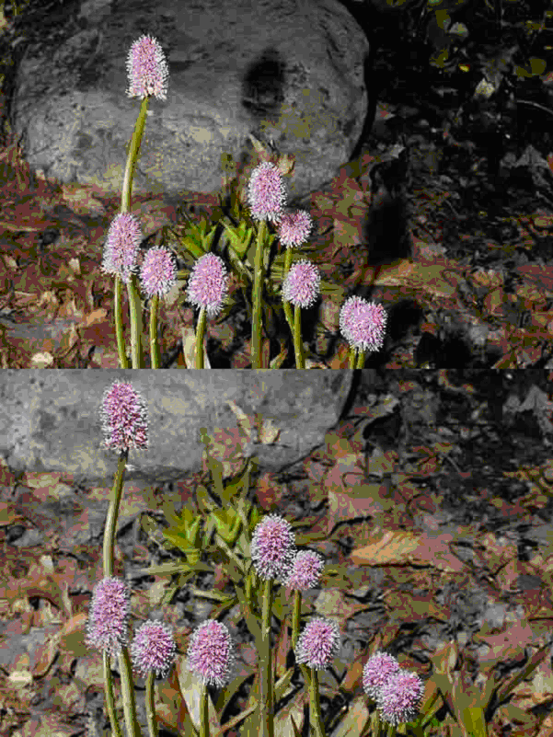
Top: One SB-800 hand held to the left of the lens.
Bottom: One SB-800 hand held to the left of the lens and another SB-800 on AS-19 to the left at ground level.
SB-800s controlled by SU-800 on camera in TTL mode.
In the bottom shot the A to B power ratio was 4:1

