Example of SB-800 Range
Prepared 2005-04-27 by Bill Claff

This shot was taken with a D70 70-210mm @210 f/4 1/250s with SB-800.
It was taken a few minutes before midnight on a dark night.
The subject is 42 feet away.
I cropped the center of the photo to simluate 420mm.
(For the purposes of responding to a post in another forum)
The bottom strip is a 100% crop from the center.
The image is untouched except for cropping and resizing.
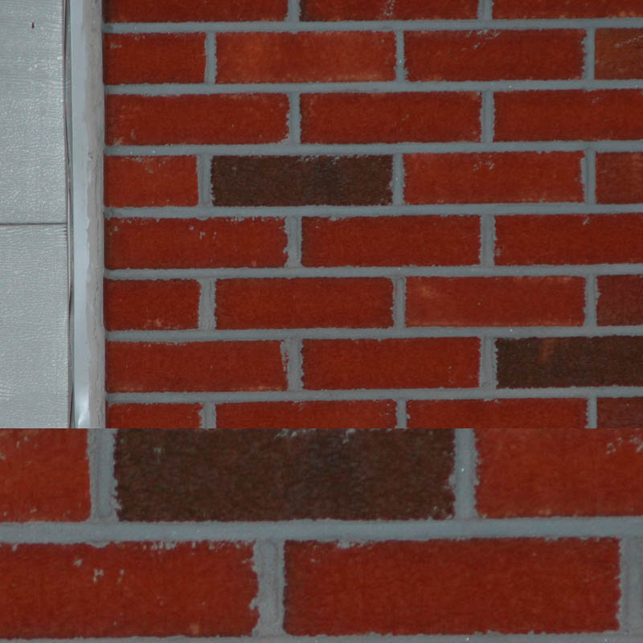

Here's another taken on the same shoot.
D70 70-210mm @70 f/4 1/250s (Manual mode) with SB-800.
The garage is over 42 feet away.
The cans and bicycle at the back of the garage are another 20 feet away.
On top is the full image (resized).
Bottom left is a 100% crop of cans and bicycle through window.
Bottom right is a 200% crop.
