Proof that CLS i-TTL Power Settings are Independent of Group
Prepared 2008-09-11 (154/34874) by Bill Claff
I shot 4 images of the same target with two SB-800s in TTL mode using an SU-800.
One SB-800 was in Group A. The other was in Group B.
Here are the resulting images, identically processed.
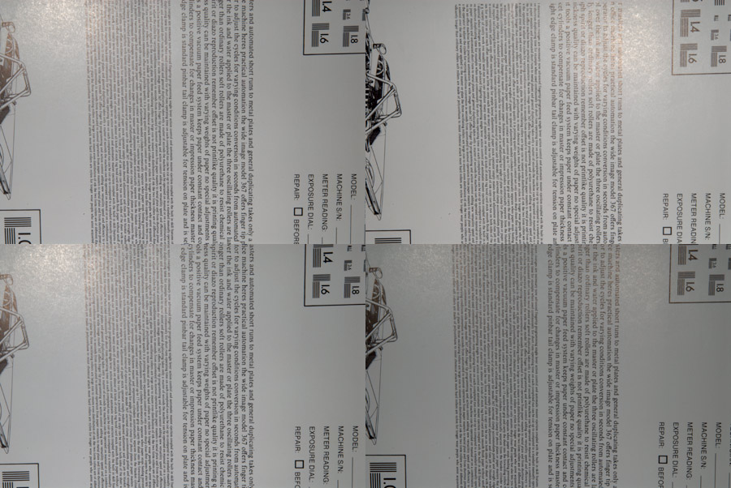
Upper left is using Group A and Group B
Upper right is using Group A
Lower left is using Group B
Lower right is using Group A and Group B but Group B was not pointed at the subject
If it isn't clear from the images, here are the histograms.
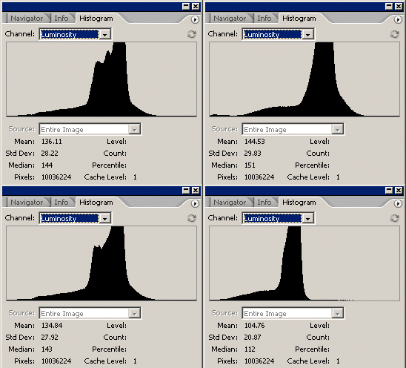
Clearly when Group B did not point at the subject; Group A was not increased in power to compensate.
I had hoped that the Nikon system was smarter than this.
That it would do all the pre-flashes and then compute all the powers.
But this test appears to confirm that power levels are set on each Group based on it's pre-flash (for i-TTL).
The practical implication would seem to be that is that it's unwise to illuminate the same portion of a subject with flashes from different Groups as their interaction is not taken into account.
(Typically, when I use more than one Group, I'm using one for "foreground" and another for "background"; and so I have never run afoul of this issue myself.)

