Quiz: Guess the Lighting Setup
Prepared 2008-01-06 by Bill Claff
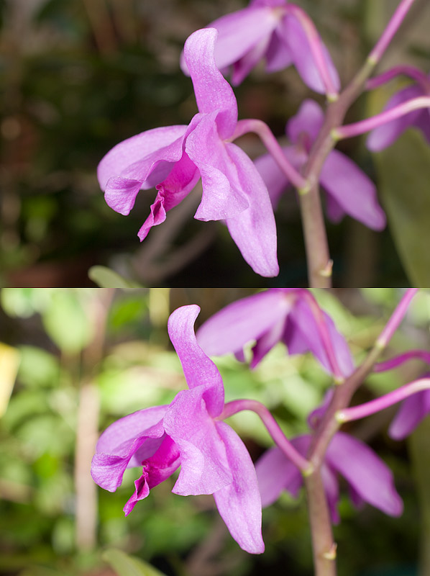
The 1st was shot with a pair of SB-R200s in the usual position on the lens.
In the 2nd shot an SB-800 was added in a separate group to light the background.
I like the contrasting colors and the less black background and think I'll shoot for something between these two in post processing.

