AF Sensor Nerdvana Achieved
Prepared 2006-01-04 (150/79706) by Bill Claff
PREFACE
I will preface this post by saying that in taking over 24,000 pictures with my D70 I have never had problem with an image that I attributed to an AF Sensor adjustment issue.
However, in more exacting tests of image sharpness; I have known for some time that my D70 has been back-focusing slightly.
So, as winter sets in; I have decided to adjust my AF accuracy.
I'll outline what I did but this procedure clearly is not for everyone.
BACKGROUND
AF accuracy depends in large part on adjusting the AF mirror.
The mirror needs to be adjusted so the distance from mirror to AF Sensor and the distance from mirror to CCD Sensor match.
The adjustment is performed by turning an elliptical peg that the mirror rests against in the D70 body.
There are two pegs, the one closer to the CCD sensor adjusts the AF mirror, the other controls the Viewfinder mirror.
The peg accepts a 2mm hex wrench.
The Viewfinder and AF mirror adjustments interact.
If I were adjusting both I would do the Viewfinder first; but my Viewfinder seemed fine so I went straight to the AF mirror adjustment.
Obviously, to perform this adjustment you need a good way to judge sharpness.
I use custom written software to analyze the raw linear data in NEF files to get an "objective" measure of sharpness.
See the cached Nikonian thread on my web site entitled A Technique for Measuring Relative Sharpness (2005-08-04 86/7071) (particularly post#7) for details.
(The average and standard deviation in Photoshop histograms could be used to approximate my technique.)
PROCEDURE
My D70 was mounted on an Adorama focusing rail (really a focusing stage) on a tripod.
My test target was alternating white and black lines on a vertically positioned LCD monitor.
(My sharpness measure requires a repeating high contrast image.)
I used a 50mm f/1.8 AF Nikkor at f/1.8 at a distance of approximately 500mm from the target.
To collect one set of data I would
- AF with a half-press of the shutter
- Switch the body from AF to M focusing
- Move the body forward 3mm
- Take 7 shots moving the body backward 1mm after each shot
- Switch the body back to AF from M focusing
The result is 7 images (from -3 to +3) centered about the AF point.
I would compute sharpness for the 7 images and plot the result.
The desired result is a U-shaped curve with 0 as the sharpest point.
Lines that slope up are front-focus; lines that slope down are back-focus.
Turn the peg CCW to fix front-focus; turn it CW to fix back-focus.
I get access to the peg the same way as I would to do a sensor cleaning.
I lock the mirror up and I take the battery out.
RESULT
After a number of attempts (10!) I have reached AF Sensor nerdvana.
Here is the chart of my attempts:
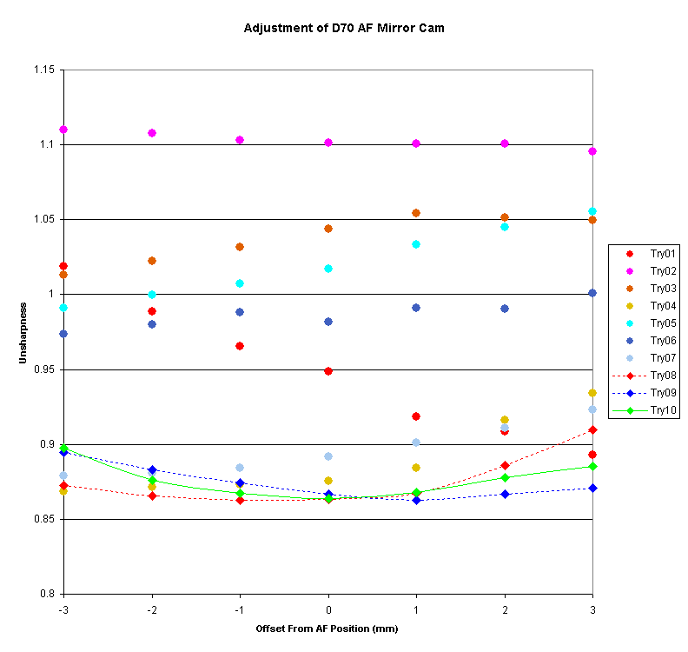
My first adjustment was in the wrong direction and then I moved slowly toward my goal.
This adjustment is quite sensitive and I think would be much more challenging without an objective way to measure sharpness.
Note that the final set of 7 images are visually identical when viewed at 100%
Here's a sharpness chart for the final cam position from -5mm to 5mm:
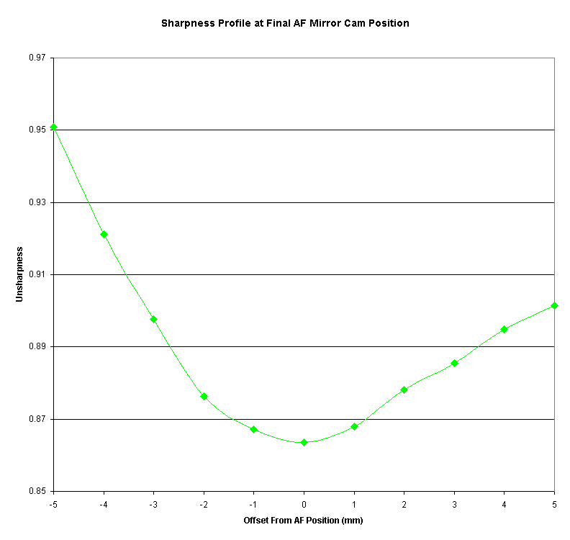
To state the obvious, I adjusted for the center AF Sensor; and the others are just along for the ride.
If the AF Sensors are not all in the same plane then the off-center sensors will be out of adjustment.
In that case I would imagine the camera would need Nikon service rather than self-adjustment.
However, in my case things look pretty good.
Here are sharpness profiles for all 5 AF sensors:
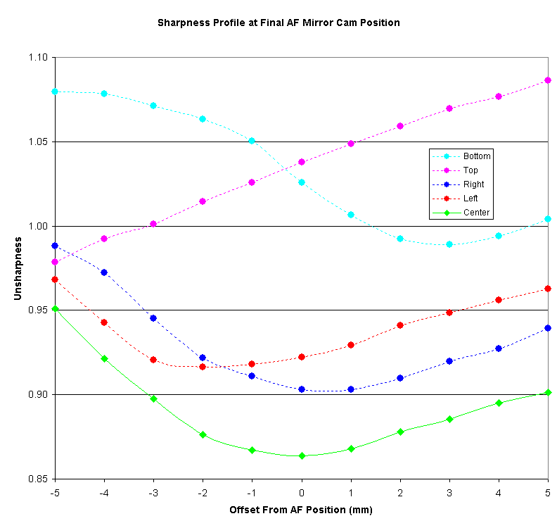
And considering that my LCD monitor might not be perfectly square to the camera I think this results is excellent.
(Looks to me to be more square left/right than up/down.)

