D300 AF-C Dynamic Focus in Action
Prepared 2008-07-17 by Bill Claff
A series of shots as I'm learning this new lens.
I'm pretty impressed with the D300 and the lens.
D300 150-500mm@400mm f/11 1/640s ISO 220-640 (ISO Auto)
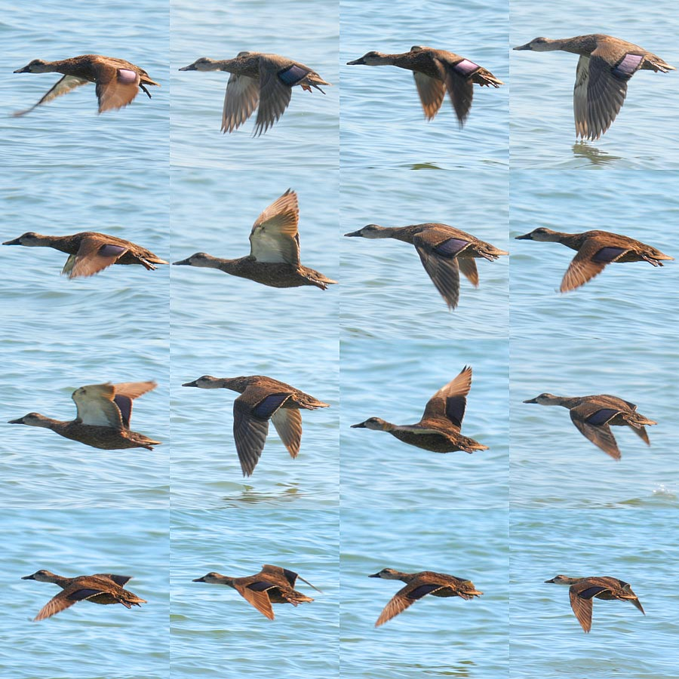
25% crops adjusted for equal brightness.
Also, FWIW, my custom relevant settings were:
a1: AF-C priority selection = Release
a3: Dynamic AF area = 9 points
a4: Focus tracking with lock-on = Normal
And firmware is version 1.03

