Focal Length at Closest Focus - Sigma 100-300mm and 150-500mm
Prepared 2008-07-05 (157/25463) by Bill Claff

More technical fodder:
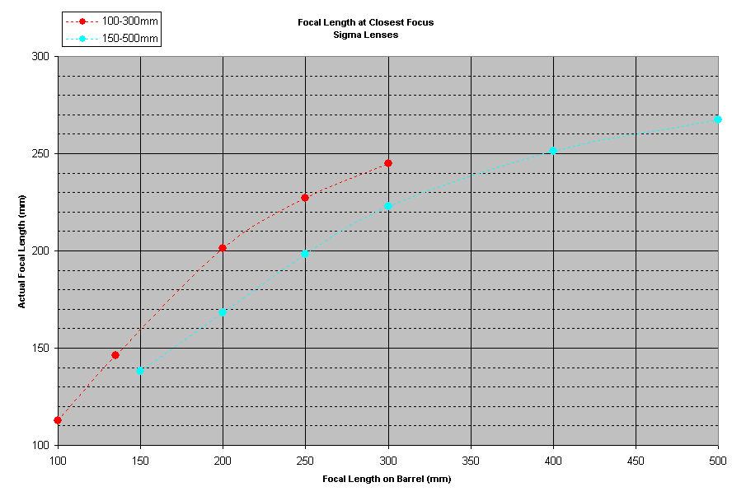
FWIW, here's a chart that shows just how linear (accurate) the data I gathered is:
