Panoramas - Finding the Entrance Pupil
Prepared 2005-05 by Bill Claff
INTRODUCTION
A panorama is a wide or expansive view. In still photography a panoramic image is one that is wider -sometimes much wider- than normal. Without a specialized camera, panoramas are formed by creating a mosaic of two or more images in a process called stitching. Although images are generally stitched horizontally they can also be stitched vertically or in both directions.
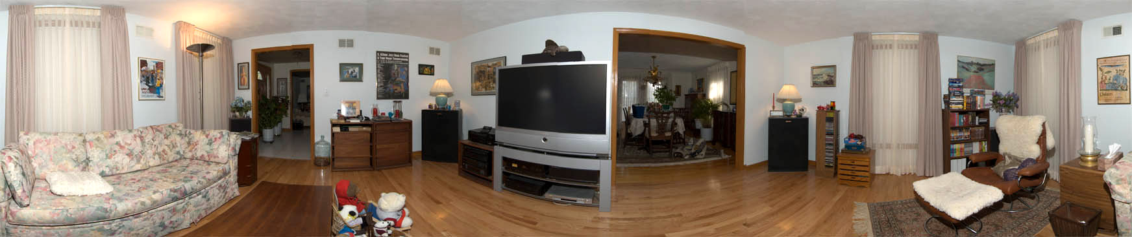
12 vertical shots stitched together
Nikon D70 with 12-24mm f/4G ED-IF AF-S DX Nikkor @ 12mm f/7.1 1/60s
With hand-held SB-800 on SC-29 cable, TTL-BL flash setting
In order for two images to stitch together properly they must be taken with the entrance pupil of the lens in the same position in space. If this requirement is not met then objects at different distances from the camera will move in relation to each other making stitching impossible. This requirement can be relaxed only for those situations where the entire scene is fairly far away and that is why the demonstration shots above were made in close quarters and not of a landscape.
ENTRANCE PUPIL
Images for a horizontal panorama are usually collected by panning the camera on a leveled tripod. But the camera is not rotated about the tripod socket but rather about the entrance pupil of the lens. The location of the entrance pupil is a function of the focal length and focus position of the lens. If you have made an investment in a panoramic head then generally locating the entrance pupil is done by trial and error.
A pair of objects, one close by and one distant are sighted through the viewfinder and the panoramic head offset is adjusted until these objects no longer move relative to each other when the camera is panned. However, if you're constructing your own panoramic setup with a fixed offset then you need to determine the offset beforehand. This tip provides a technique for locating the entrance pupil without requiring a fancy panoramic head.
A METHOD
I want to share this method that I used to locate the rotation point for my 12-24mm @ 12mm and it worked quite well.
I will be referring to the following diagram.
I took an ordinary 8 1/2x11 inch sheet of paper.
I drew two isosceles triangles with a base of 120mm and heights of 180mm and 240mm. These triangles represent 1/2 the horizontal field of view at infinity at 18mm and 24mm focal lengths respectively.
(Notice 120mm is 10*(24mm/2), 180mm is 10*18mm, and 240mm is 10*24mm.)
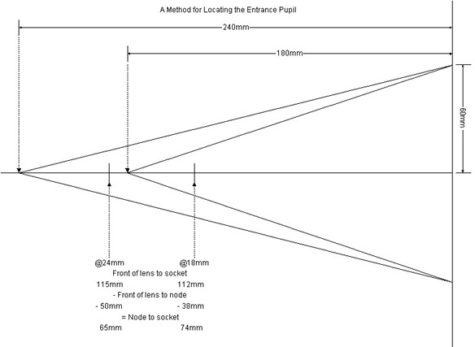
- I set the Focus-mode selector on my D70 body to M.
- I set the focus on the lens to infinity.
- I place the paper on a flat brightly lit surface.
- I set the aperture for f/8 and the focal length to 12mm.
- I turn the grid lines on in the viewfinder.
- With the camera turned on and the depth of field preview button depressed, I position the camera on the paper so the long sides of the 18mm triangle matched the 1/4 and 3/4 grid lines.
- I mark the position of the front edge of the lens on the paper.
- I turn that camera over and measured the distance from the front edge of the lens to the middle of the tripod socket.
- I measure the distance from the marked position on the paper to the triangle vertex.
- The difference in these measurements is the distance from the tripod socket to the entrance pupil. I repeated the procedure at 24mm.
According to my results the distances from the tripod socket forward to the entrance pupil is 74mm at 18mm focal length and 65mm at 24mm focal length.
BTW, the 12-24mm at 12mm has a socket-to-node distance of 100mm.

