Be Not Afraid
Prepared 2005-05-25 by Bill Claff
Do not be afraid to use a circular polarizing filter on a wide lens!
Just use your head, or rather your eyes; if it looks good through the lens, then go for it!
Here is an example:
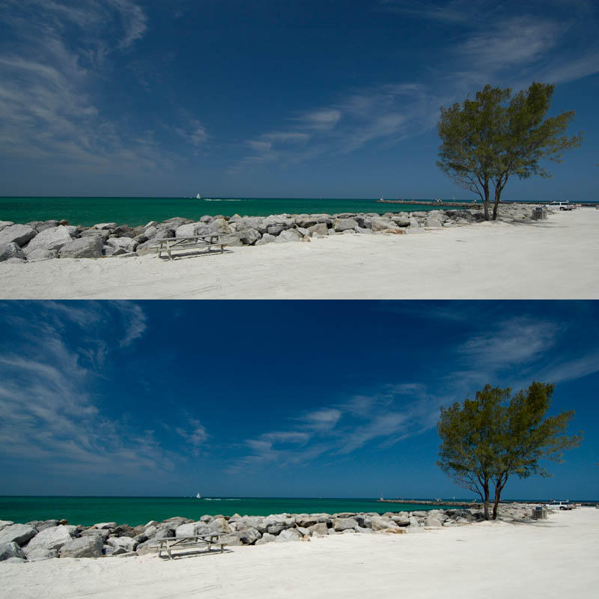
Top is cropped from 3008x2000 to 3000x1500 and resized, nothing else.
Bottom is the same with some exposure and shadow adjustment.
Taken with D70 12-24mm@12mm f/7.1 1/400s with circular polarizing filter.

