Circular Polarizer Example
Prepared 2005-02-16 by Bill Claff
Circular Polarizer Example

I thought I would share this example from my collection.
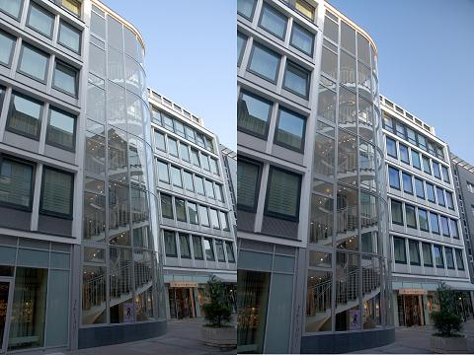
Right after I took the shot on the left I gave myself a "dope slap" and put the circular polarizer on for a second shot. With the polarizer the interesting stairway detail that I was after is much nicer. The darker blue sky is just a bonus There is also a hint or purple in the office windows, probably due to some coating on the windows.
I find a circular polarizer very useful but rarely have side by side shots to compare.

