Color Space Basics
Prepared 2007-12-15 by Bill Claff

Introduction
A color space defines a coordinate system for colors.
All devices that capture or render color have a color space.
Color spaces are based on three (or more) color points and a white point in a standard reference space.
The white point is somewhat misnamed as it (generally) represents all shades of white, including black.
Also, the definition of “white” is, in itself, a complicated subject, not covered here.
Many of the color spaces we deal with are based on red, green, and blue; we call these RGB color spaces.
RGB color spaces include almost all cameras, display devices, and many printers.
But many other printers use other color spaces based on CMY (cyan, magenta, and yellow).
Unless otherwise noted, in this article when I say color space I mean an RGB color space.
The four points form a coordinate system having an origin at the white/black point and where each of the color points are the unit x-axis, unit y-axis, and unit z-axis of a 3-dimensional system.
These coordinates and additional information are typically stored in an ICC (International Color Consortium) color profile.

Introduction to CIE (International Commission on Illumination) 1931 Diagrams
It’s useful to project the 3-dimensional coordinate system onto 2 dimensions for discussion.
It’s important not to lose sight of the fact that these are only 2 dimensional projections.
In particular, comparing the areas of two color spaces underestimates the difference in volume of those color spaces.
Although not ideal, the most widespread representation used for color spaces is the CIE 1931 diagram.
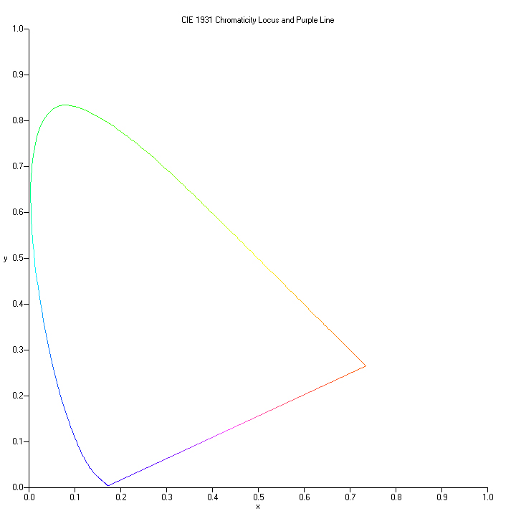
The horseshoe shaped portion of this diagram represents the spectral colors with wavelengths from 360nm to 830nm.
The location of the chromaticity locus was determined empirically in 1931 by the CIE.
The straight line connecting the ends of the horseshoe is the “purple line”.
Colors along this line are combinations of light at wavelengths of 360nm and 830nm.

Tristimulus and Color Gamuts
RGB color spaces are tristimulus color spaces. They combine up to three stimulus colors to represent a single color.
On a CIE 1931 diagram the three tristimulus colors form a triangle.
Only colors that lie along the edge or inside of the triangle can be represented in the color space.
The range of color that can be represented by a color space is called the gamut.
Here is a diagram showing the color gamuts of three color spaces:
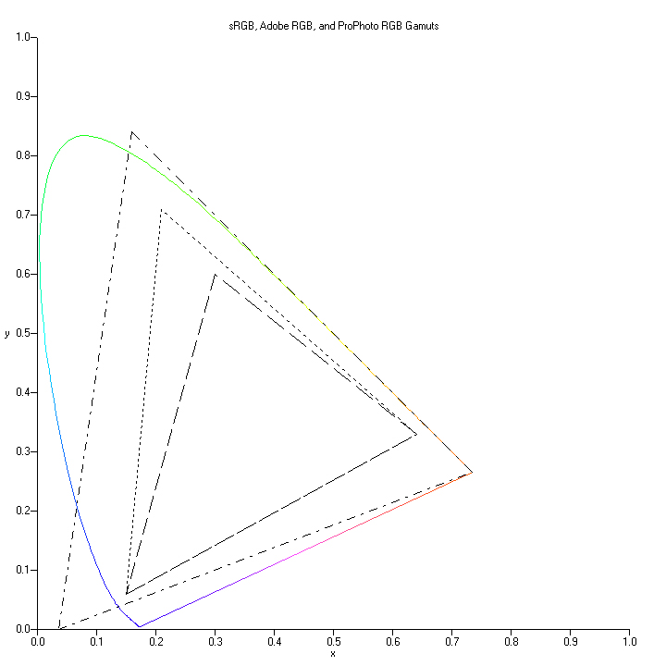
The smallest gamut shown here is sRGB. Adobe RGB has a larger gamut, extending further toward green.
ProPhoto RGB has a significantly larger gamut than either sRGB or Adobe RGB.

Conclusion
This simple introduction serves as a foundation for understanding the choice of color space as a working space and other topics such as white balance.

