HDR Example – Lights burning out Interior Shots
Prepared 5-04-15 by Bill Claff
I've been playing with this on and off.
I chose a very difficult subject for a demonstration.
This is my kitchen with under counter and ceiling lighting all on.
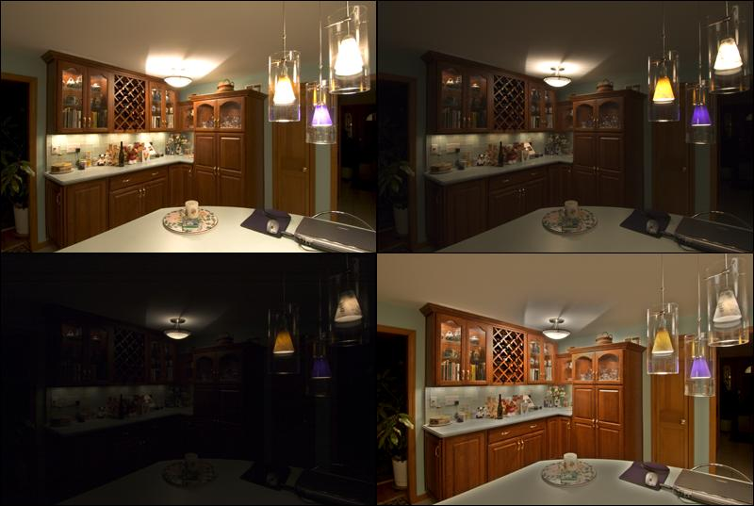
D70 with 12-24mm Nikkor @12mm f/8 ISO 200
The upper left shot is an unprocessed "normal" shot with lights "blown out". (1/3rd sec)
The upper right and lower left are unprocessed shots at higher shutter speeds. (1/15th sec and 1/250th sec)
The lower right is a blend of all three done in Photoshop CS.
I have to say, I'm quite pleased with my first attempt at blending.

