Constructing a Spectral Locus
Prepared 2014-04-20 by Bill Claff

I find it helpful to visualize a Spectral Locus on a CIE 1931 style chart.
If spectral sensitivity data in a tabular form are not available then the first step is to gather such information from any published spectral sensitivity chart.
In locating such a chart it's important that an IR cut or other filter is included rather than just showing the sensitivity of the bare sensor.
For the Foveon X3 this is the chart I started with:
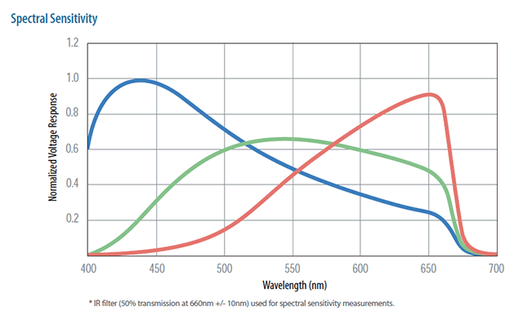
Somehow you need to read the values off of the chart for each of the channels.
I use a technique with Microsoft Excel to accomplish this.
I create a scatter chart overlaying the spectral sensitivity chart and adjust values until I have the proper fit.
For example:
The colored circles on the chart represent the data points being read off of the curves on the background image.
In the following table these are the CIE X, CIE Y, and CIE Z columns:
nm | CIE X | CIE Y | CIE Z | CIE x | CIE y | CIE z
400 | 0.5 | 0 | 64 | 0.007752 | 0.000000 | 0.992248
410 | 0.5 | 3.5 | 84.5 | 0.005650 | 0.039548 | 0.954802
420 | 0.75 | 8 | 93.5 | 0.007335 | 0.078240 | 0.914425
430 | 1.5 | 14.5 | 98 | 0.013158 | 0.127193 | 0.859649
440 | 2.25 | 22.5 | 99 | 0.018182 | 0.181818 | 0.800000
450 | 3 | 30.5 | 97.5 | 0.022901 | 0.232824 | 0.744275
460 | 4.5 | 38 | 94 | 0.032967 | 0.278388 | 0.688645
470 | 6 | 45 | 89 | 0.042857 | 0.321429 | 0.635714
480 | 8 | 51 | 83 | 0.056338 | 0.359155 | 0.584507
490 | 11 | 56 | 77 | 0.076389 | 0.388889 | 0.534722
500 | 14.5 | 59.5 | 71.5 | 0.099656 | 0.408935 | 0.491409
510 | 19 | 62.5 | 66 | 0.128814 | 0.423729 | 0.447458
520 | 25 | 64.5 | 61.5 | 0.165563 | 0.427152 | 0.407285
530 | 32 | 65.5 | 57 | 0.207120 | 0.423948 | 0.368932
540 | 38.5 | 66 | 53 | 0.244444 | 0.419048 | 0.336508
550 | 45.5 | 66 | 49 | 0.283489 | 0.411215 | 0.305296
560 | 51.5 | 65.5 | 46 | 0.315951 | 0.401840 | 0.282209
570 | 57 | 64.5 | 42.75 | 0.347032 | 0.392694 | 0.260274
580 | 62.5 | 63 | 40 | 0.377644 | 0.380665 | 0.241692
590 | 68 | 61.5 | 37 | 0.408408 | 0.369369 | 0.222222
600 | 73 | 60 | 34.5 | 0.435821 | 0.358209 | 0.205970
610 | 78 | 58 | 32 | 0.464286 | 0.345238 | 0.190476
620 | 82 | 56 | 30 | 0.488095 | 0.333333 | 0.178571
630 | 86 | 53.75 | 28 | 0.512668 | 0.320417 | 0.166915
640 | 89 | 51.25 | 26 | 0.535338 | 0.308271 | 0.156391
650 | 91 | 48 | 24.5 | 0.556575 | 0.293578 | 0.149847
660 | 85 | 40.5 | 20.5 | 0.582192 | 0.277397 | 0.140411
670 | 35 | 15 | 8 | 0.603448 | 0.258621 | 0.137931
680 | 5 | 1.9 | 1.1 | 0.625000 | 0.237500 | 0.137500
690 | 1.5 | 0.5 | 0.3 | 0.652174 | 0.217391 | 0.130435
700 | 0.5 | 0.15 | 0.1 | 0.666667 | 0.200000 | 0.133333
Note that CIE x, CIE y, and CIE z are simply the CIE X, CIE Y, and CIE Z values normalized to sum to 1.
The coloring indicates the dominant CIE x, CIE y, and CIE z values.
A scatter chart of the CIE x versus CIE y values produces the Spectral Locus:
This chart also shows the red, green, and blue dominant wavelengths as colored circles.
Getting very small values such as those at 690nm and 700nm can be tricky.
If the Spectral Locus behaves badly then small values like these may need some adjustment.

