D300 (and D3) Gain
Prepared 2008-03-03 (149/117257) by Bill Claff

With the right test images it's not too hard to measure sensor gain, where gain is the number of Analog to Digital Units (ADUs) per electron.
(See 'Photon Transfer Curve' at my site for background.)
This result is also often reported as electrons/ADU, which is technically the inverse gain, but so long as the units are present the meaning is "obvious".
Here is a table of measured values (electrons/ADU):
ISO | D300_12 | D300_14 | D3_12 | D3_14
100 | 6.26 | 1.63 | 16.64 | 3.96
200 | 5.11 | 1.27 | 15.51 | 3.88
400 | 2.38 | 0.60 | 7.59 | 1.84
800 | 1.23 | 0.30 | 3.57 | 0.91
1600 | 0.63 | 0.15 | 1.86 | 0.46
3200 | 0.31 | 0.07 | 0.93 | 0.24
6400 |  | 0.04 | 0.48 | 0.12
12800 |  |  | 0.24 | 0.06
25600 |  |  | 0.12 | 0.03
Note#1: I forgot to collect a value for D300_12 at ISO 6400
Note#2: The value for D3_12 at ISO 800 looks like "bad" data
The following chart shows that these values are quite linear, with slopes of 1; which is to be expected:
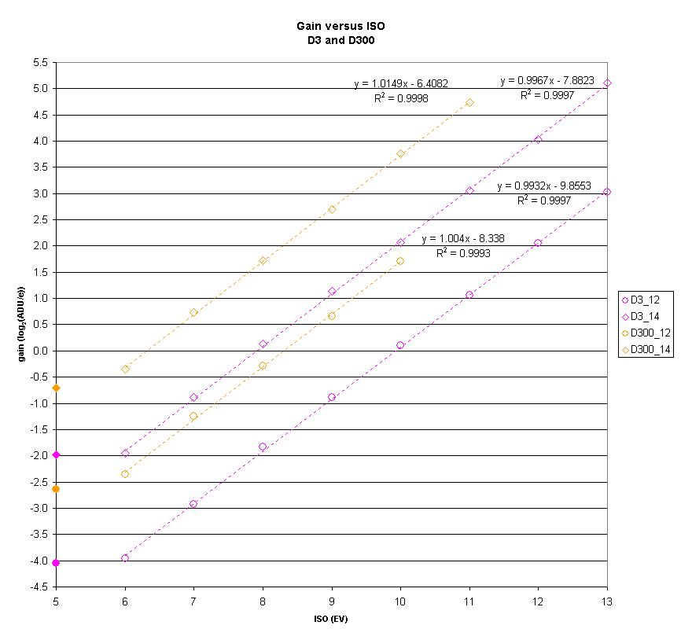
Shown as a log-log chart for clarity.
Note that the ISO 100 values, shown with closed symbols, are not in line with the values for the other ISOs.
This is because the native sensitivity of the sensor is higher than ISO 100 and any gain below the native sensitivity would not use the full range of the Analog to Digital Converter (ADC).
That is why these values are called "Lo" rather than being numbered.
A different technique, which will be the subject of a separate post, can be used to identify the "Hi" ISO values.

