D300 (and D3) Read Noise
Prepared 2008-03-04 (149/117423) by Bill Claff

With the right test images and procedure (see Read Noise on my site) it is not too difficult to measure Read Noise (RN).
Read noise is an important, sometimes dominant, component of noise in the dark areas of an image.
Here is a table of measured values (in ADUs):
ISO | D300_12 | D300_14 | D3_12 | D3_14
100 | 1.74 | 6.66
200 | 2.12 | 8.13 | 1.27 | 4.73
400 | 3.97 | 15.22 | 1.90 | 6.86
800 | 7.59 | 28.66 | 3.01 | 11.85
1600 | 14.39 | 54.12 | 5.85 | 20.25
3200 | 16.10 | 60.32 | 11.35 | 38.84
6400 |  | 59.96 | 21.23 | 78.07
12800 |  |  | 22.03
25600 |  |  | 21.68
Note: A few non-essential values are missing.
The following chart shows these values as a function of ISO:
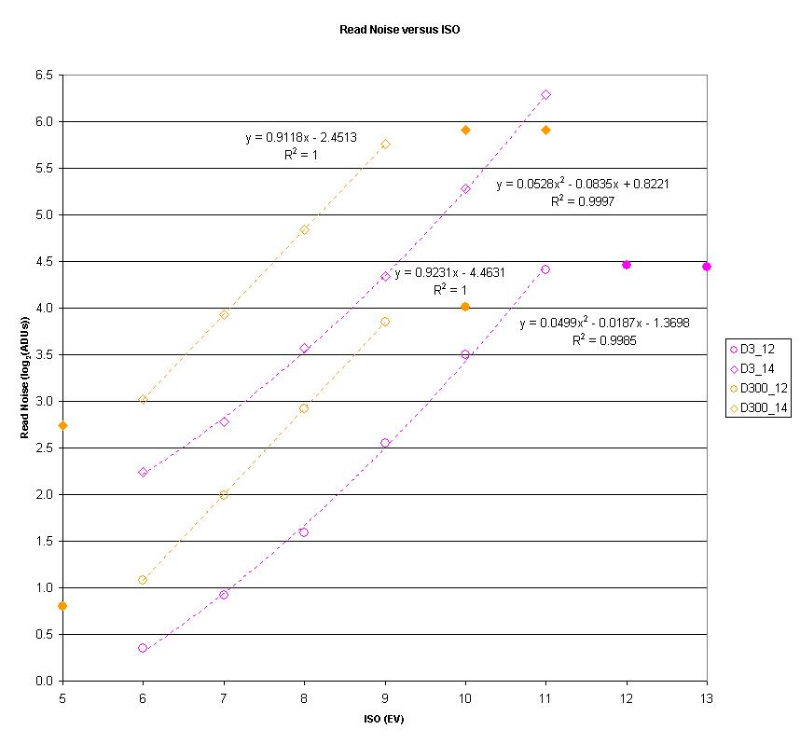
Shown as a log-log chart for clarity.
The open symbols represent the numbered ISO values while the closed symbols represent to "Lo" and "Hi" values.
The dotted lines are curve fits.
The equations and R² are shown to illustrate how close the fit is.
Note that the "Lo" and "Hi" values do not lie on the dotted lines.
The "Lo" values are slightly below the lowest numbered ISO value, and the "Hi" values are about the same as the highest numbered ISO value.
The behavior of the "Lo" values is due to the gain values discussed in D300 (and D3) Gain.
The behavior of the "Hi" values is due to the fact that these ISO equivalents result from post-ADC multiplication rather than pre-ADC amplification.
It's also interesting to note that for every camera for which I have data the dotted curve fit is linear except for the D3.
I believe this implies some sort of two-stage amplification; presumably to reduce noise.

