D700 Read Noise
Prepared 2011-12-17 by Bill Claff

The D700 Read Noise values were determined from the Optical Black data in NEF files.
Here is a table of measured values (in ADUs):
ISO | noise  ADU | gain  e⁻/ADU | noise  e⁻
100 | 3.959 | 3.852 | 15.251
125 | 3.988 | 3.852 | 15.365
158 | 3.956 | 3.852 | 15.241
200 | 3.985 | 3.852 | 15.351
251 | 4.956 | 3.058 | 15.153
317 | 6.292 | 2.427 | 15.269
400 | 4.422 | 1.926 | 8.518
503 | 5.615 | 1.529 | 8.584
634 | 7.062 | 1.213 | 8.569
800 | 5.896 | 0.963 | 5.679
1007 | 7.548 | 0.764 | 5.769
1269 | 9.210 | 0.607 | 5.588
1600 | 12.296 | 0.482 | 5.921
2015 | 15.075 | 0.382 | 5.762
2539 | 18.643 | 0.303 | 5.655
3200 | 23.765 | 0.241 | 5.722
4031 | 30.348 | 0.191 | 5.799
5079 | 37.813 | 0.152 | 5.735
6400 | 48.506 | 0.120 | 5.839
8063 | 30.205 | 0.120 | 3.636
10159 | 38.100 | 0.120 | 4.587
12800 | 48.646 | 0.120 | 5.856
25600 | 48.948 | 0.120 | 5.892
The following chart shows these values as a function of ISO:
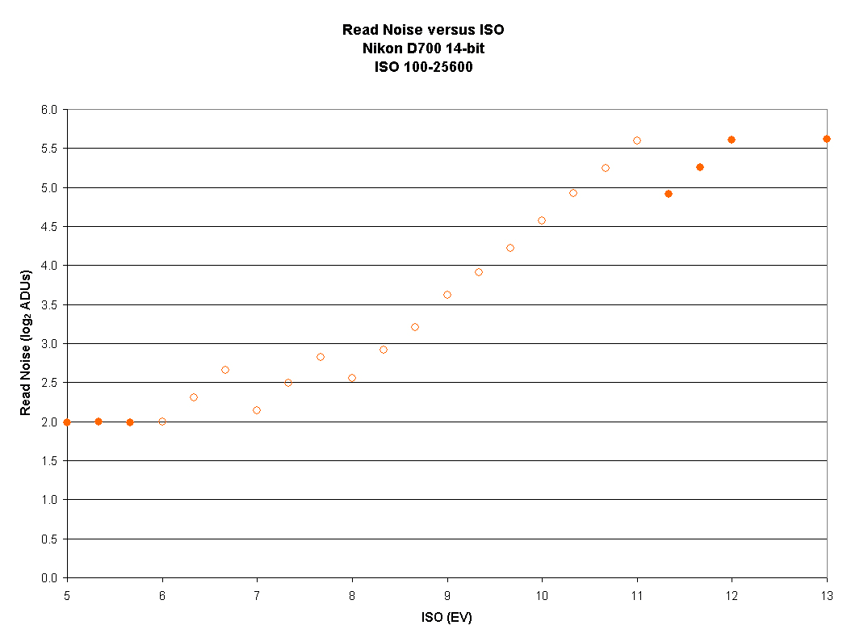
Shown as a log-log chart for clarity.
The open symbols represent the numbered ISO values while the closed symbols represent to "Lo" and "Hi" values.
The stepped nature of the open symbols implies a two stage amplification process.

