Sony A7RM2 DR-Pix Read Noise
Prepared 2015-08-29 by Bill Claff

This article presents analysis results only. For background see Sony A7S DR-Pix Read Noise.
The Sony A7RM2

This table summarizes the calculations for all of the ISO settings:
 | model |  |  |  |  |  |  | measured
ISO | pixel | conversion | conversion | intermediate | conversion | conversion | read | read
Setting | noise | gain | noise | noise | gain | noise | noise | noise
 | e- | e-/e- | e- | e- | DN/e- | DN | DN | DN
100 | 0.925 | 1.000 | 2.906 | 3.050 | 0.315 | 1.223 | 1.555 | 1.413
125 | 0.925 | 1.000 | 2.906 | 3.050 | 0.397 | 1.223 | 1.721 | 1.666
160 | 0.925 | 1.000 | 2.906 | 3.050 | 0.500 | 1.223 | 1.955 | 1.964
200 | 0.925 | 1.000 | 2.906 | 3.050 | 0.630 | 1.223 | 2.277 | 2.329
250 | 0.925 | 1.000 | 2.906 | 3.050 | 0.794 | 1.223 | 2.712 | 2.778
320 | 0.925 | 1.000 | 2.906 | 3.050 | 1.000 | 1.223 | 3.286 | 3.357
400 | 0.925 | 1.000 | 2.906 | 3.050 | 1.260 | 1.223 | 4.032 | 4.045
500 | 0.925 | 1.000 | 2.906 | 3.050 | 1.587 | 1.223 | 4.993 | 4.918
640 | 0.925 | 6.350 | 2.906 | 6.553 | 0.315 | 1.223 | 2.399 | 2.418
800 | 0.925 | 6.350 | 2.906 | 6.553 | 0.397 | 1.223 | 2.874 | 2.940
1000 | 0.925 | 6.350 | 2.906 | 6.553 | 0.500 | 1.223 | 3.497 | 3.555
1250 | 0.925 | 6.350 | 2.906 | 6.553 | 0.630 | 1.223 | 4.305 | 4.356
1600 | 0.925 | 6.350 | 2.906 | 6.553 | 0.794 | 1.223 | 5.343 | 5.318
2000 | 0.925 | 6.350 | 2.906 | 6.553 | 1.000 | 1.223 | 6.666 | 6.737
2500 | 0.925 | 6.350 | 2.906 | 6.553 | 1.260 | 1.223 | 8.346 | 8.433
3200 | 0.925 | 6.350 | 2.906 | 6.553 | 1.587 | 1.223 | 10.474 | 10.310
You can see by examining the table or the following chart that the model read noise and the measured read noise agree quite well.
(This is a log-log chart and the small discrepancies are generally well within a 1/6EV tolerance.)
However, agreement above ISO 3200 diverges as if there is a small amount of noise reduction. This is still under investigation.
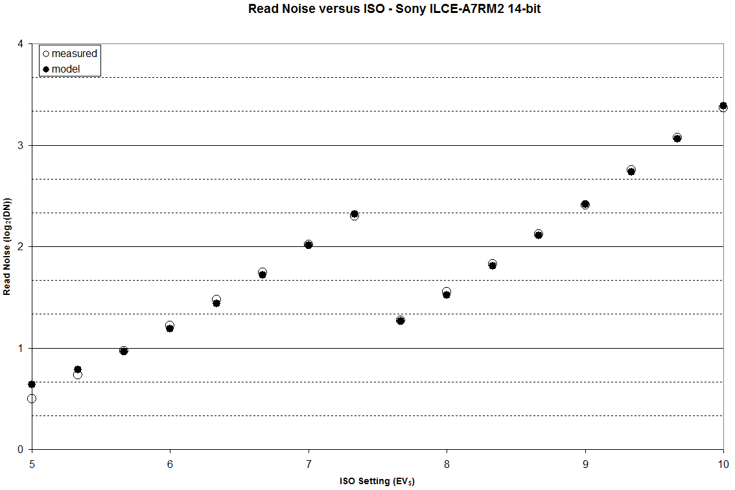
Conclusion
I have demonstrated that to characterize read noise of the A7RM2, incorporating DR-Pix technology, that only three values are required: 0.925e- pixel noise, 2.906e- pixel conversion noise, and 1.223DN ADC conversion noise. (And unity gain of 318 to compute the conversion gains to feed in.)
Addendum
This chart shows graphically how measured read noise (in DN) drops steadily below the model above ISO 3200 (EV_{S} 10)
