Spectral Response of Bayer and X3
Prepared 2014-04-20 by Bill Claff (revised 2014-04-21)

As a framework for visualizing the Spectral Locus and Planckian locus I will be using CIE xyY charts based on CIE 1931.
There is a wealth of information on CIE 1931 and later CIE color spaces as well as how to convert a spectral response to a Spectral Locus and how to compute blackbody values elsewhere. This background material is not covered in this article.
Note that the nature of CIE 1931 is that only the bottom left half of the square is used.

Also note that two CIE 1931 charts with different Spectral Loci are not comparable as the color represented by a CIE x and CIE y coordinate pair is a function of the Spectral Locus and the whitepoint.
On these charts the Spectral Locus represents monochromatic light at a particular wavelength.
Red, green, and blue are indicated at the 700nm, 520nm, and 400nm wavelength respectively with colored circles.
The Purple Line is a straight line joining the endpoints of the spectral locus.
The Planckian Locus shows the path of the white point from 0 degrees Kelvin on the right to infinity on the left.
The black box on the Planckian locus indicates 6500K, approximately daylight
Human Response
Here's the chart showing for the typical human:
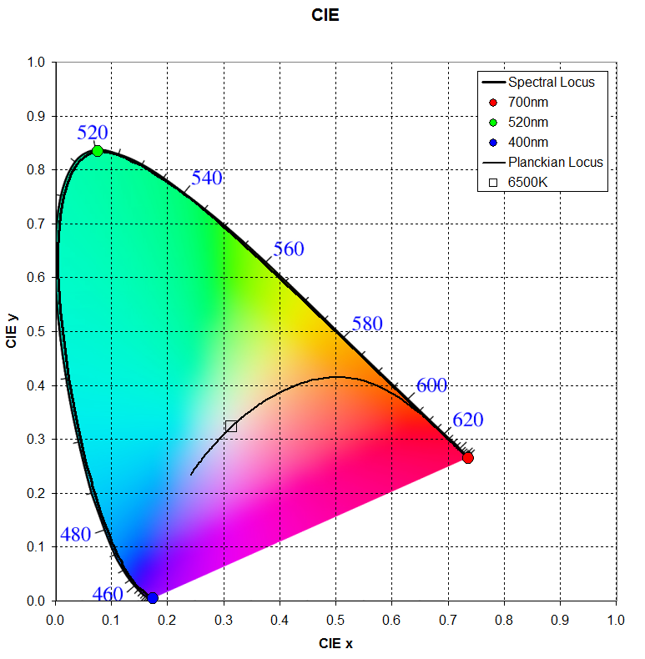
The colored background is representative, not perfect.
Note that saturation increases from 0% to 100% between the white point and the Spectral Locus or Purple Line.
Bayer Response
As a representative Bayer response I've used data from a Sony ICX413AQ as was used in the Nikon D70 camera.
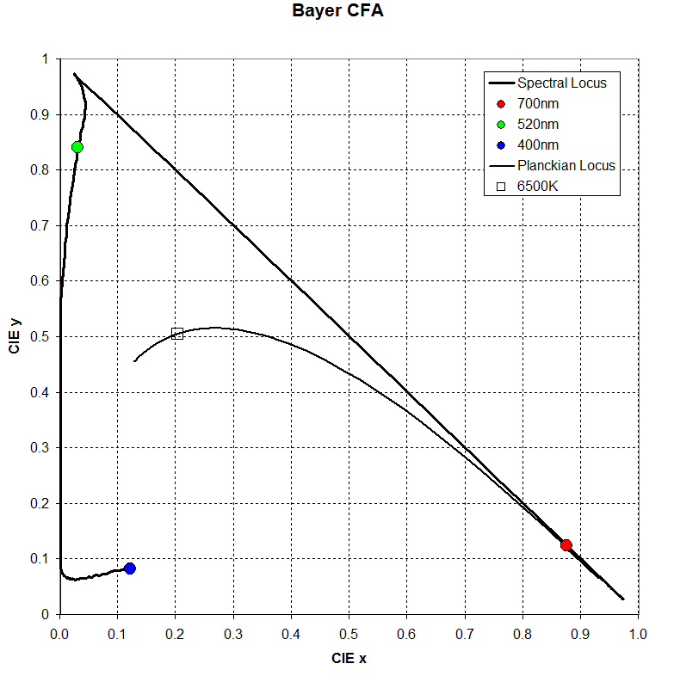
The Spectral Locus is huge, nearly covering the entire triangle.
X3 Response
As the representative X3 response I've used data from a frequently published X3 spectral response diagram.
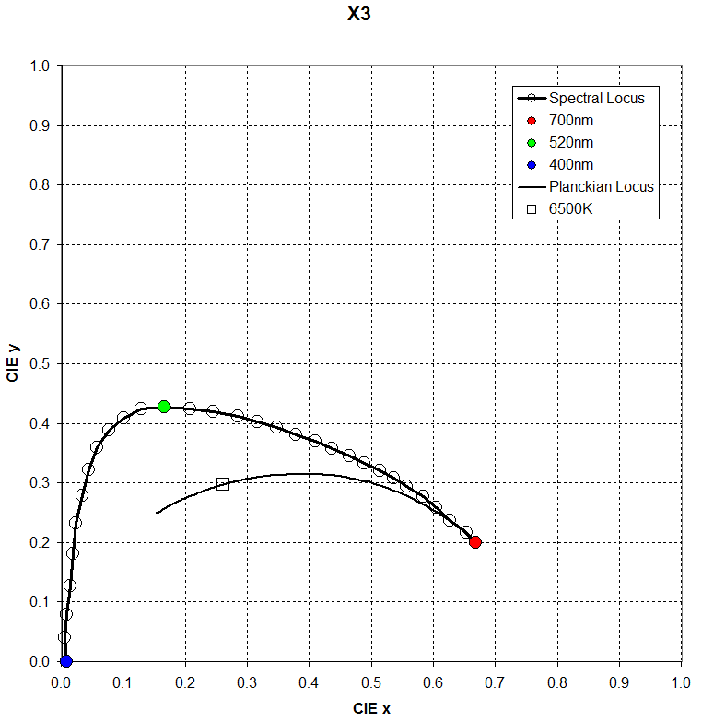
On this chart Spectral Locus the open circles are placed every 10nm as a visualization aid.
This Spectral Locus is much smaller than the Bayer.
Discussion
Pretty much any Spectral Locus can be used to capture complete color information in an image.
To reconstitute it for an accurate presentation to a human viewer requires transformations.
Those transformations are easier and more accurate when the Spectral Locus used for the capture is close to that of the human response.
It appears that getting accurate color reproduction from an X3 sensor is inherently more difficult than from a Bayer.

