SD9 Dark Frame Investigation
Prepared 2014-04-15 by Bill Claff Revised 2014-04-19
The article presents various aspects in the investigation of a dark frame from a Sigma SD9.
The raw X3F image was taken in Manual mode, f/22, 1/6000s, at ISO 100.
Read Noise
The dark frame produced a very well behaved scatter chart:
showing a Read Noise (RN) of 6.9 linearized Analog to Digital Units (ADUs).
The gaps and low values at -6 and +6 appear to be due to the linearization process.
Sigma Photo Pro (SPP) Output
Jpeg output from SPP with defaults settings is extremely consistent.
Every pixel in Adobe Photoshop has an RGB value of 3,3,3; a perfect almost black.
Given the actual read noise in the raw data; the processed file is too good to be true.
Adobe DNG Output
When run through Adobe DNG Converter and then into Adobe Photoshop the result is more interesting.
This image was put through a drastic curves command to bring out the subtleties and is cropped at 100%:
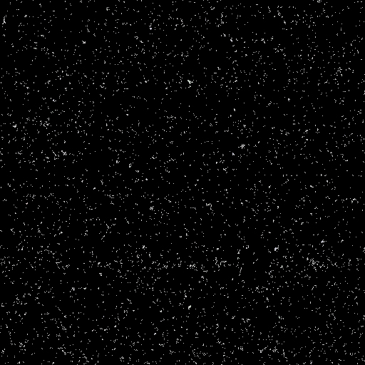
In the full version of this image it's more clear that there is some horizontal banding.
ImageJ Analysis
A 256x256 region of the blue top plane was extracted from the center of the image.
Here the horizontal banding is more evident (the other planes look similar):
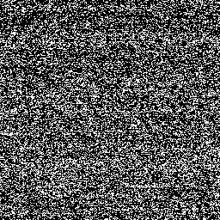
And for good measure the 2d FFT:
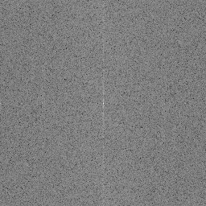
The white vertical line is a clear indication of the horizontal banding as well
Conclusion
Banding in a dark frame is usually indicative of banding in normal exposures.
The amount of banding seen here is not unusual in my experience.
How apparent that banding is would be the subject of a separate investigation.

